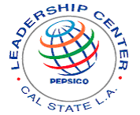
Cal State Los Angeles

PepsiCo Leadership Center
Presents:
Do you want to go to College?
Then join us . . .
Saturday
October 20th


For a workshop on . . .
How to apply for College and health & wellness

(Parents are Welcome!!!)

Time: 9:00 a.m. to Noon
Location: Reiterman House
LEARN ABOUT:
Students attending our two workshops (10/13 & 10/20/07) will be eligible to attend a free field trip event.
- College admission tests
- Interviewing techniques
- College applications
- Timelines
For more information contact:
PepsiCo Leadership Center
California State University, Los Angeles
Library North, Room 1014A
5151 State University Drive
Los Angeles, CA 90032
(323) 343-5270 leadctr@calstatela.edu
Website: www.calstatela.edu/centers/leadctr

- Common mistakes

ALSO:

• Be mentored by a college student
• PepsiCo snacks will be provided!

